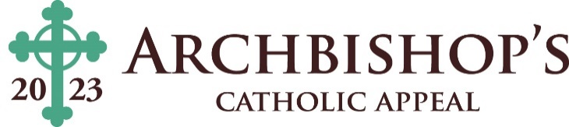

“Envelope” Cash Donations
Parish Name
Parish Number
Parish Address
City/Zip Code
Phone Number
Parish Contact

Denomination | Quantity | Total Cash
Coins: | ------------------------------- | $
$1 Bills |  | $
$5 Bills |  | $
$10 Bills |  | $
$20 Bills |  | $
$50 Bills |  | $
$100 Bills |  | $
Grand Total Cash | ------------------------------- | $

Parish Employee #1 Signature
Parish Employee #2 Signature
Parish Check Date and Check Number | / /2023 ------- Check #

- Deposit cash into parish bank account and issue a check for the same amount made payable to: Archbishop’s Catholic Appeal.

- Attach the signed parish check to this form.

- Return the completed form, the signed parish check, and “in-pew” donation envelopes to the Archbishop’s Catholic Appeal Office by using the 10” x 13” business-reply envelope that was included in your parish kit. Thank you.

DON’T FORGET TO ATTACH A SIGNED PARISH CHECK. DO NOT MAIL CASH

Questions? Please contact the Archbishop’s Catholic Appeal Office at (720) 476-7466.

