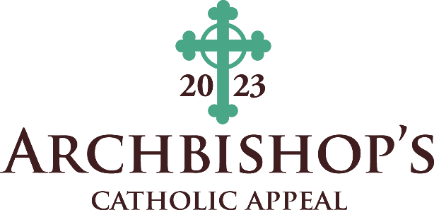
Bulletin Announcements

April 15-16
(ANNOUNCEMENT WEEKEND
Join us NEXT WEEKEND for the special release of the latest Archbishop’s Catholic Appeal video. Help grow hope, education, and faith through a donation to the appeal which supports more than 40 ministries that answer the needs of our neighbors each day. To make an immediate impact on our faith community visit www.archden.org/givetoday or call 303-867-0614.
April 22-23
(APPEAL COMMITMENT WEEKEND)
Don’t miss your chance to see the archbishop’s message about being “Rooted in Christ, Spreading His message and Sharing His fruit” for the 2023 Archbishop’s Catholic Appeal in the new video at http://www.archden.org/givetoday. Your gift helps others grow in their relationship with Christ through more than 40 ministries and helps support our parish. Make your gift today!
April 29-30
(APPEAL FOLLOW-UP WEEKEND)
“It is more blessed to give than to receive.” (Acts 20:35). Your sacrifice will affirm your desire to make Jesus Christ known to others. Please visit www.archden.org/givetoday or call 303-867-0614 to give to the Archbishop’s Catholic Appeal.
May 6-7
Join, TODAY, the growing number of parishioners who abide in relationship with Christ and share His fruit with a monthly recurring gift to the Archbishop’s Catholic Appeal by visiting www.archden.org/givetoday or call 303-867-0614.

May 13-14
Gifts to the Archbishop’s Catholic Appeal are immediately invested in works of mercy, education, and charity. To make an immediate impact on our faith community visit www.archden.org/givetoday or call 303-867-0614.
May 20-21
Being rooted in Christ means spreading His message and sharing His fruits with our neighbors. Join us, with a monthly recurring gift to the Archbishop’s Catholic Appeal at www.archden.org/givetoday or call 303-867-0614.

