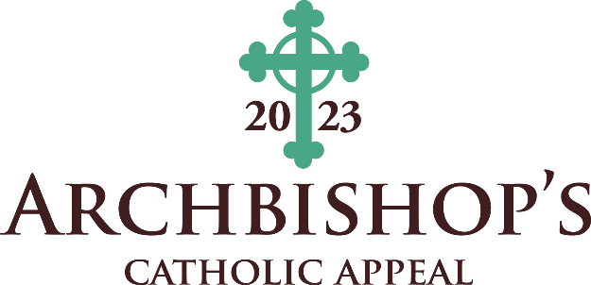

INTERCESSIONS
April 15-16
(ANNOUNCEMENT WEEKEND)
Intercession
That the good works that are rooted in Christ, through the ministries supported by the Archbishop’s Catholic Appeal, give witness to the message of the Gospel — we pray to the Lord.
April 22-23
(APPEAL COMMITMENT WEEKEND)
Intercession
That our neighbors, who will be lifted up by the Church mission rooted in Christ and supported by this year’s Archbishop’s Catholic Appeal, find renewed hope to abide in their relationship with Jesus Christ — we pray to the Lord.
April 29-30
(APPEAL FOLLOW-UP WEEKEND)
Intercession
That God will bless the works of service that are done by the archdiocese ministries that are rooted in Christ and supported by the Archbishop’s Catholic Appeal — we pray to the Lord.

May 6-7
Intercession
For our neighbors who will experience the love of the Gospel from those who are rooted in Christ, spreading His mission and sharing His fruit to the Archbishop’s Catholic Appeal, we pray to the Lord.

May 13-14
Intercession
That the Gospel message of Jesus Christ will be witnessed in the good works of service rooted in His name through the support of the Archbishop’s Catholic Appeal, we pray to the Lord.

May 20-21
Intercession
That God’s infinite love and mercy will shine upon the archdiocese ministries rooted in Christ and supported by this year’s Archbishop’s Catholic Appeal, we pray to the Lord.

