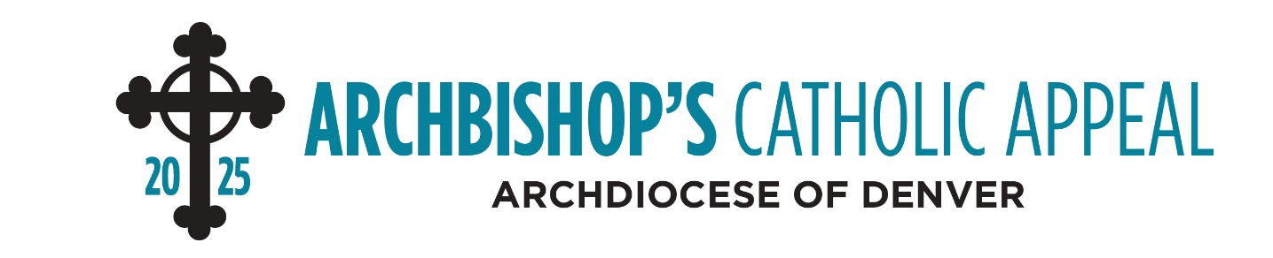

Bulletin Announcements

April 26-27
(ANNOUNCEMENT WEEKEND
Join us next weekend for the special release of the latest Archbishop’s Catholic Appeal video. This year, consider making a gift to the appeal, which extends the love of Jesus through various ministries that care for the needs of our neighbors each day. To give today visit archden.org/givetoday or call 303-867-0614.

May 3-4
(APPEAL COMMITMENT WEEKEND)
See the Archbishop’s message for the 2025 Archbishop’s Catholic Appeal in the new video at archden.org/givetoday. Your gift is an act of love for the Lord, helping others grow in their relationship with Christ through various ministries that support Northern Colorado. Give today!

May 10-11
(APPEAL FOLLOW-UP WEEKEND)
Love is more than a feeling — it is an action. Your generosity is an expression of Christ’s love, bringing hope and healing to those in need. Join the mission by giving today at archden.org/givetoday or call 303-867-0614.

