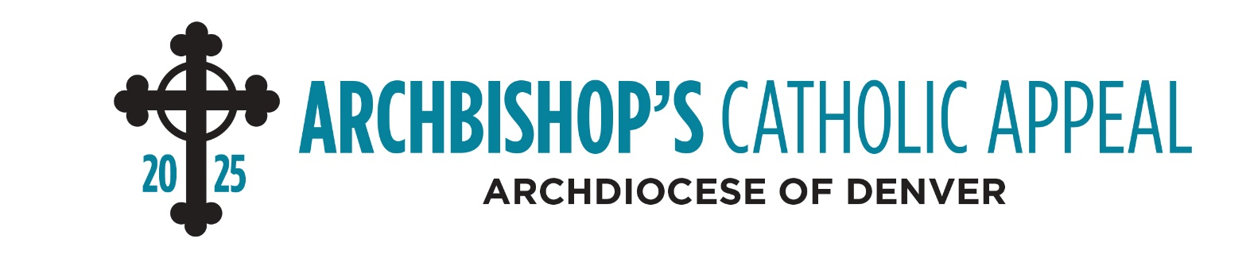

INTERCESSIONS

April 26-27
(ANNOUNCEMENT WEEKEND)
Intercession
That the good works that flow from the ministries supported by the Archbishop’s Catholic Appeal extend the love of Jesus to our community, we pray to the Lord.

May 3-4
(APPEAL COMMITMENT WEEKEND)
Intercession
That those in our community may feel Christ’s love and presence from the impact of the many ministries supported by this year’s Archbishop’s Catholic Appeal, we pray to the Lord.

May 10-11
(APPEAL FOLLOW-UP WEEKEND)
Intercession
That God will bless and inspire all ministries that help rescue souls through the proclamation of the Gospel, especially those supported by the Archbishop’s Catholic Appeal, we pray to the Lord.
May 17-18
Intercession
That through the ministries supported by the Archbishop’s Catholic Appeal, many will experience the love of Jesus Christ, we pray to the Lord.

May 24-25
Intercession
That the works of mercy and charity which the Archbishop's Catholic Appeal enables and supports will always witness to the Gospel message of Jesus Christ, we pray to the Lord.

May 31- June 1
Intercession
That God’s infinite love and mercy will shine upon all of the archdiocesan ministries supported by this year’s Archbishop’s Catholic Appeal, we pray to the Lord.

