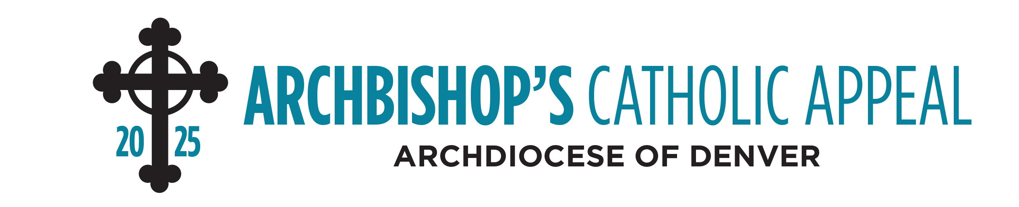
“Loose” Cash Donations
Parish Name
Parish Number
Parish Address
City/Zip Code
Phone Number
Parish Contact

Denomination | Quantity | Total Cash
Coins: | -------------------------------à | $
$1 Bills |  | $
$5 Bills |  | $
$10 Bills |  | $
$20 Bills |  | $
$50 Bills |  | $
$100 Bills |  | $
Grand Total Cash | -------------------------------à | $

Parish Employee Signature
Parish Employee Signature
Parish Check Date and Check Number | / /2025 ------ Check #

● Deposit cash into parish bank account and issue a check for the same amount made payable to: Archbishop’s Catholic Appeal.

● Attach the signed parish check to this form.

● Return the completed form and the signed parish check to the Archbishop’s Catholic Appeal Office by using the 10” x 13” business-reply envelope that was included in your parish kit. Thank you.

DON’T FORGET TO ATTACH A SIGNED PARISH CHECK. DO NOT MAIL CASH

Questions? Please contact the Donor Relations Department at (303) 867-0614.

