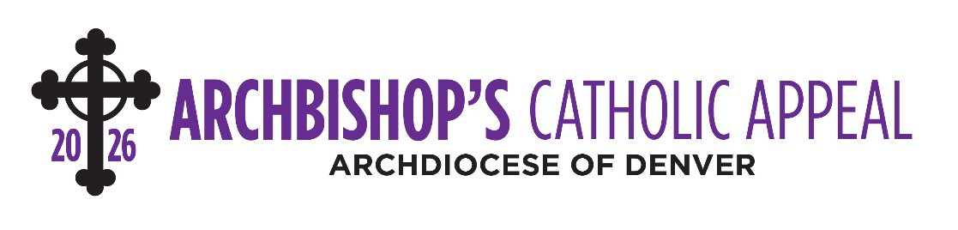
Bulletin Announcements

April 11-12
(ANNOUNCEMENT WEEKEND
Join us next weekend for the special release of the Archbishop’s Catholic Appeal video. This year’s theme reminds us that everything we have is a gift from God. In gratitude for all He has given us, we are invited to share those gifts through the Appeal, which extends the love of Jesus through ministries that care for our neighbors each day.
To make your gift today, visit archden.org/givetoday or call 303-867-0614.

April 18-19
(APPEAL COMMITMENT WEEKEND)
See the Archbishop’s message for the 2026 Archbishop’s Catholic Appeal in the new video at archden.org/givetoday. As we reflect that everything we have is a gift from God, we are called to respond with grateful hearts. Your gift is an act of thanksgiving and love for the Lord, helping others grow in their relationship with Christ through ministries serving Northern Colorado.
Give today and share the gifts God has entrusted to you.

April 25-26
(APPEAL FOLLOW-UP WEEKEND)
Everything we have is a gift from God — and love calls us to share those gifts. Your generosity is a grateful response to the Lord’s blessings, bringing hope and healing to those in need.
Join the mission by giving today at archden.org/givetoday or call 303-867-0614.

