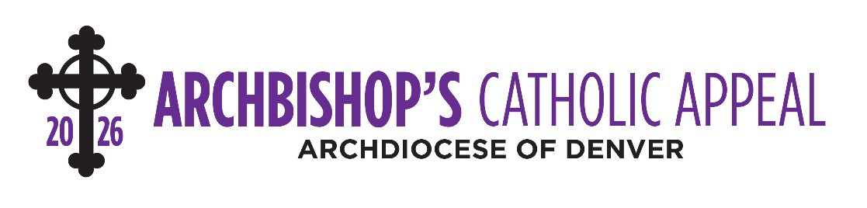
INTERCESSIONS

April 11-12
(ANNOUNCEMENT WEEKEND)
Intercession
That the ministries supported by the Archbishop’s Catholic Appeal may continue to extend the love of Jesus to our community through their good wors, we pray to the Lord.

April 18-19
(APPEAL COMMITMENT WEEKEND)
Intercession
That those in our community may feel Christ’s love and presence from the impact of the many ministries supported by this year’s Archbishop’s Catholic Appeal, we pray to the Lord.

April 25-26
(APPEAL FOLLOW-UP WEEKEND)
Intercession
That God will bless and inspire all ministries that help rescue souls through the proclamation of the Gospel, especially those supported by the Archbishop’s Catholic Appeal, we pray to the Lord.
May 2-3
Intercession
That through the ministries supported by the Archbishop’s Catholic Appeal, many will experience the love of Jesus Christ, we pray to the Lord.

May 9-10
Intercession
That God’s infinite love and mercy will shine upon all of the archdiocesan ministries supported by this year’s Archbishop’s Catholic Appeal, we pray to the Lord.

